Online-only Content

# eAppendix

A directed acyclic graph (DAG) showing our working hypothetical causal structure is presented in eFigure 1. Under our working assumptions, reducing the risk of worker exit prior to retirement would reduce the risk of suicide and fatal overdose. Note that underlying depression was unmeasured. By conditioning on calendar time and plant, the causal parents of plant closure, we partially reduced the magnitude of confounding bias through that path.

Histograms of age at death among those who died of suicide and fatal overdose are presented in eFigure 2.

Employment status was determined using worker exit dates from company job records. If a case occurred after worker exit, their exit date should precede their date of death. If a case occurred while employed, their exit date should equal their death date. However, we expected the exit dates to be imperfectly recorded, given the administrative nature of the data. We attempted to characterize the extent of possible misclassification by examining the distribution of the difference between the dates of death and exit.

The left-side panel of eFigure 3 presents a histogram of the difference between death and exit dates for suicide cases. The distribution had a strong right-skew and a striking mode in the third bin, representing cases whose death date was later than their exit date and less than or equal to one year after exit. Among cases that occurred within a year of job exit, the distribution still showed a strong right skew, but with two local modes centered approximately around 0 and 33 days. The observed times centered around 0 were roughly bounded by a radius of 14 days (see eFigure 3b).

In the main analysis, we assumed that cases occurred while employed if the death date preceded or equaled the recorded exit date. In the sensitivity analysis we assumed that a case occurred while employed if the death date was within a week of the exit date. That is, we assumed that all the cases whose exit dates preceded their death dates by no more than one week were misclassified as not employed at death when they were in fact employed (see right-side of Table 2).

To estimate the hazard ratio for a more temporally-proximate outcome, we restricted follow-up to more than five years after worker exit. eTable 1 presents hazard ratio estimates for suicide and the combined outcome within 5 years after worker exit.

To better understand the shape of the exposure-outcome relationship, we fitted models which included a restricted penalized spline function (*df*= 4) of continuous age at exit.2 To fit these splines and compute hazard ratio estimates, we assumed that the hazard associated with age at exit was constant for those who left work at 55 or older, conditioning on all other covariates. To complement the analyses for categorical age at exit presented in the main body, we fitted these models for suicide and for the combined outcome (eFigure 5).

Online-only tables and figures

**eFigure 1. Directed acyclic graph representing our working causal assumptions.**

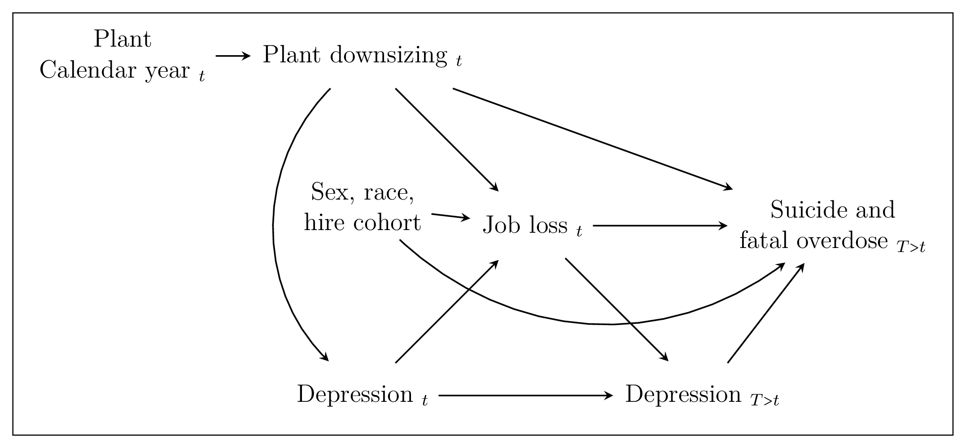

**eFigure 2. Histograms of age at death among suicide and fatal overdose cases in the UAW-GM Cohort restricted to men employed in or after 1970.**

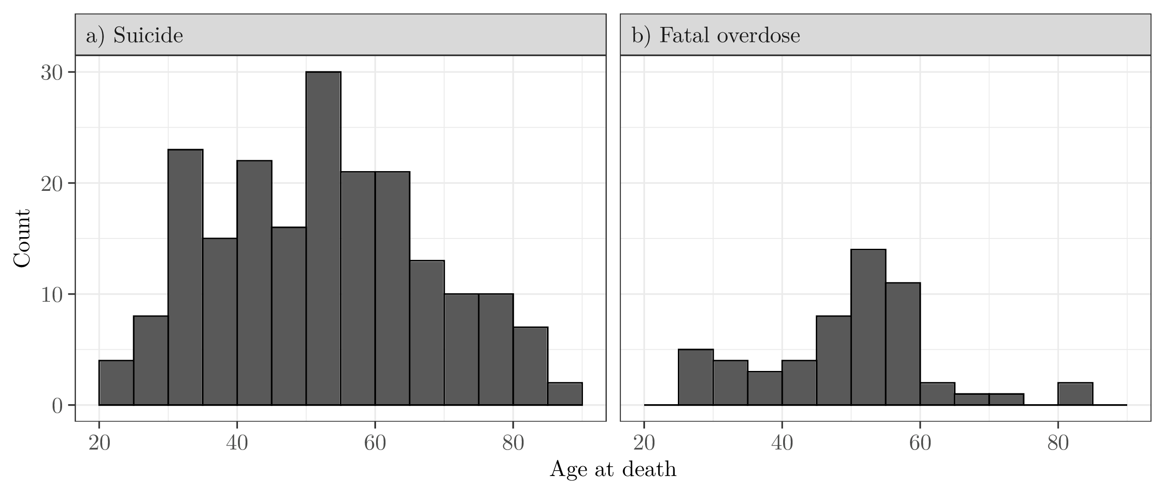

**eFigure 3. Histograms of time between worker exit date and date of suicide in the UAW-GM Cohort restricted to men employed in or after 1970. Bins corresponding to cases that occurred while employed are indicated in purple.**

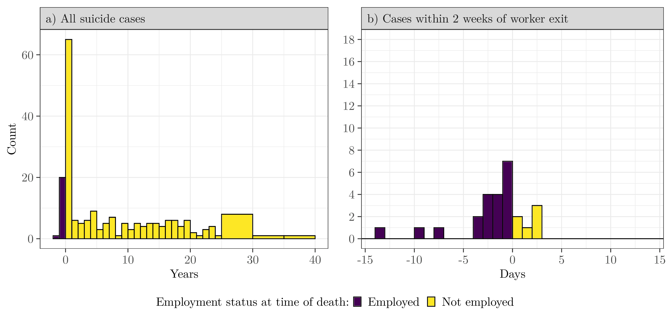

**eTable 1. Adjusted hazard ratio estimates for suicide and the combined outcome of suicide and fatal overdose in the UAW-GM Cohort, within five years of worker exit, restricted to men employed in or after 1970 who left work by December 31, 1994.**

|  |  |  |  |  |  |  |  |  |
| --- | --- | --- | --- | --- | --- | --- | --- | --- |
|  |  | Suicide | | |  | Suicide and fatal overdose | | |
| Age at worker exit |  | $$n$$ | HR | (95% CI) |  | $$n$$ | HR | (95% CI) |
| $55$ or older |  | $$28$$ | $$1.0$$ | – |  | $$30$$ | $$1.0$$ | – |
| $40$ to $54$ |  | $$28$$ | $$1.3$$ | $$(0.8, 2.3)$$ |  | $$29$$ | $$1.3$$ | $$(0.8, 2.3)$$ |
| $30$ to $39$ |  | $$21$$ | $$1.7$$ | $$(1.0, 3.0)$$ |  | $$26$$ | $$2.0$$ | $$(1.2, 3.4)$$ |
| $19$ to $29$ |  | $$9$$ | $$1.2$$ | $$(0.5, 2.6)$$ |  | $$13$$ | $$1.7$$ | $$(0.8, 3.4)$$ |
| Estimates were adjusted for race, plant, and worker exit date. Risk sets were indexed by time since worker exit. Women and those with unknown date of worker exit were excluded from this analysis. | | | | | | | | |

**eFigure 4. Continuous adjusted hazard ratio estimates for suicide and the combined outcome of suicide and fatal overdose in the UAW-GM Cohort restricted to men employed in or after 1970.**

